## Alex Goulden

## Section A

## Part 1: Review client requirements

Review the client requirements in the scenario. Based on your review, complete the following tasks and record the information in a word-processed document. Use specialised and technical language and diagrams where appropriate.

1. Create an appropriately sequenced schedule of the activities you need to complete for this project, according to the client’s timeframe (this can be in a table). This must include specific tasks for planning, sequencing, and prioritising for this website.

|  |  |  |
| --- | --- | --- |
| Step | Activity | Schedule |
| Discussions | Talking with client about specifics, target audience, requirements, ect. | Initial step day 1 |
| Mock-ups / initial design | Trialling concepts and working on revisions | Moving into production day 3 |
| HTML and CSS | Build styled version of site meeting responsive requirements and homepage/footer requirements | Day 7 |
| PHP and database | Integrate backend, data table and form | Day 11 |
| Adding content | Filling in the site with design inclusions, content, images | Day 12 |
| Final testing / debugging and touch-ups | Reviewing the site, checking all requirements were met | Complete Day 14 |

1. Describe main uses of the website.

The main use of the website is to inform and direct customers to the physical store and wares

1. Create a persona of a typical visitor to the website.

Someone who understands vinyl to some degree or is a collector, who knows what they are looking for. Most likely a local or someone out of town visiting the area

1. List the web page components (content) that the client has provided you with.
   * Is the provided content suitable for inclusion? Why or why not?

Much of it makes sense, however, it is very very dated and restricts how well I could make it modern and creatively appealing to a standard consumer

1. List the sections of a web page that are required for an effective layout, as well as those that the client has requested.

Header, navbar, Body, table, Form, Footer

1. Determine what pages are required for the website and build a suitable sitemap.

Home, retro records, rare lps, used records, privacy/copyright page, about us/contact page

1. Design and build wireframes that depict the structure for the Home and Contact pages. Include the following:
   * Required sections as listed in Task 5 above
   * Specific measurements or proportions of each section.
   * Mobile version

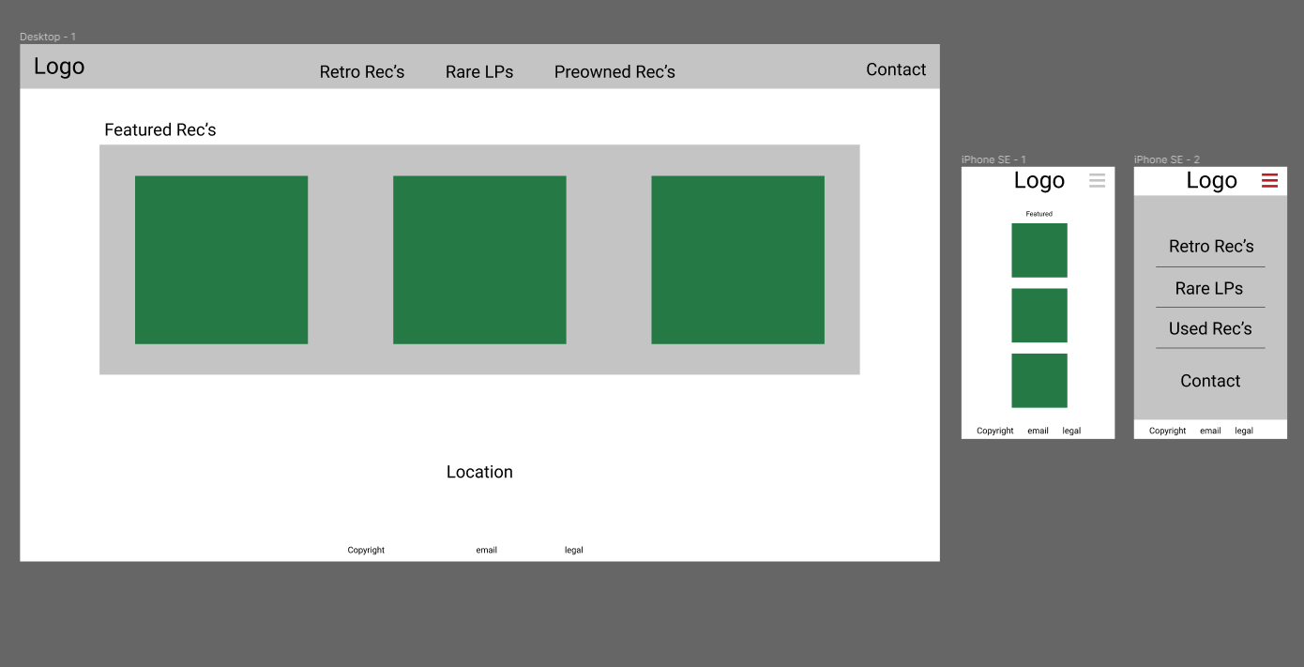

1. Select the most appropriate mark-up language to meet all the requirements for the site, its uses and audience, as well as industry best practice, and discuss why this is the best choice.

HTML – it is purpose built for the web, can be used to achieve everything we need, it is the foundation for creating any form of website and everyone uses it when interacting with websites, it is best practiced with indentation as it is built to be highly readable.

**Identify and refine client requirements**

Question 1: What stylistic inspirations / similar websites can you share that your wish your website to achieve

Question 2: To what extent do you want your forms / tables to be integrated and autonomous

## Part 2: Test and validate the website

Now that you have completed creating the website, it’s time for you to test and validate it. Record your test results (including screenshots where indicated) in a word-processed document to provide to the client. Use specialised language where appropriate.

1. Make sure that your testing includes the following:
   * Test your website in at least two common browsers; if you have difficulty accessing different browsers and versions you can use an online testing site such as [Browser Shots](http://browsershots.org/) (include screenshots)

Chrome

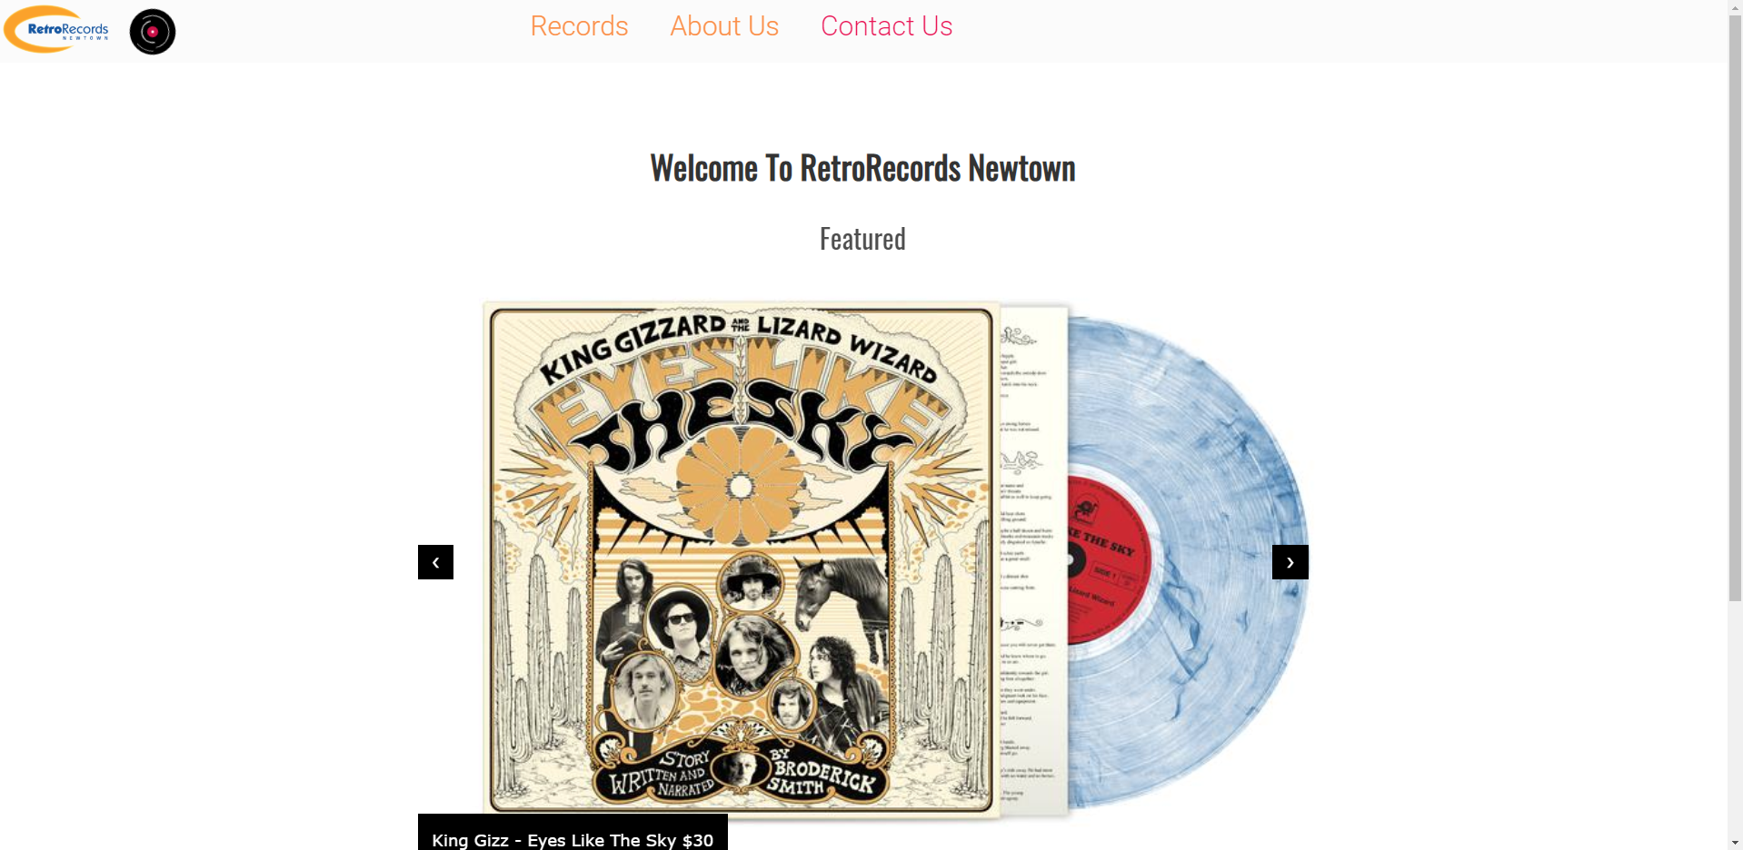

Edge

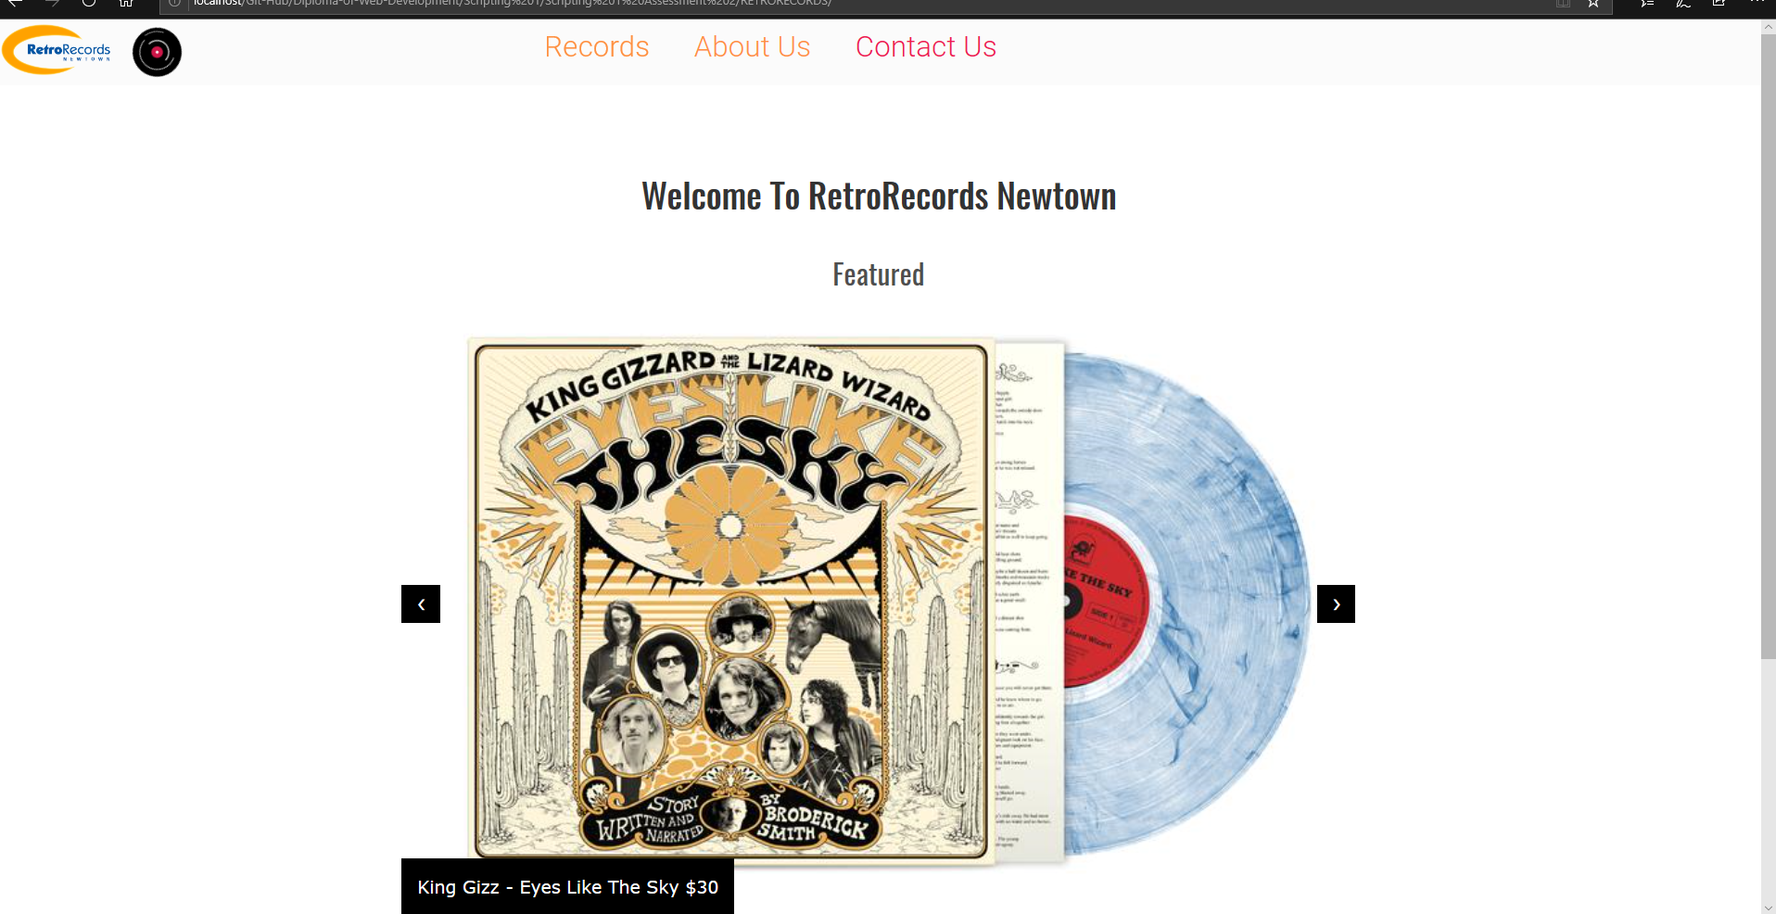

* + Test in mobile device or emulator to make sure the site is responsive according to the breakpoints set in your CSS media queries.

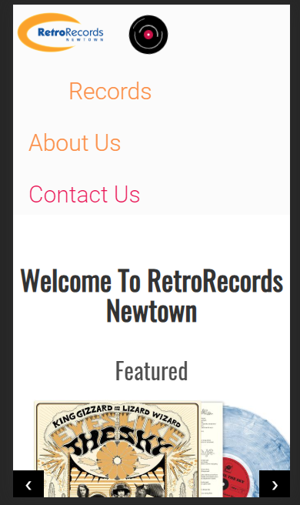

* + Validate your website to ensure it meets web standards (include screenshots) for HTML and CSS.

VALIDATION / RESOLUTIONS:

Html

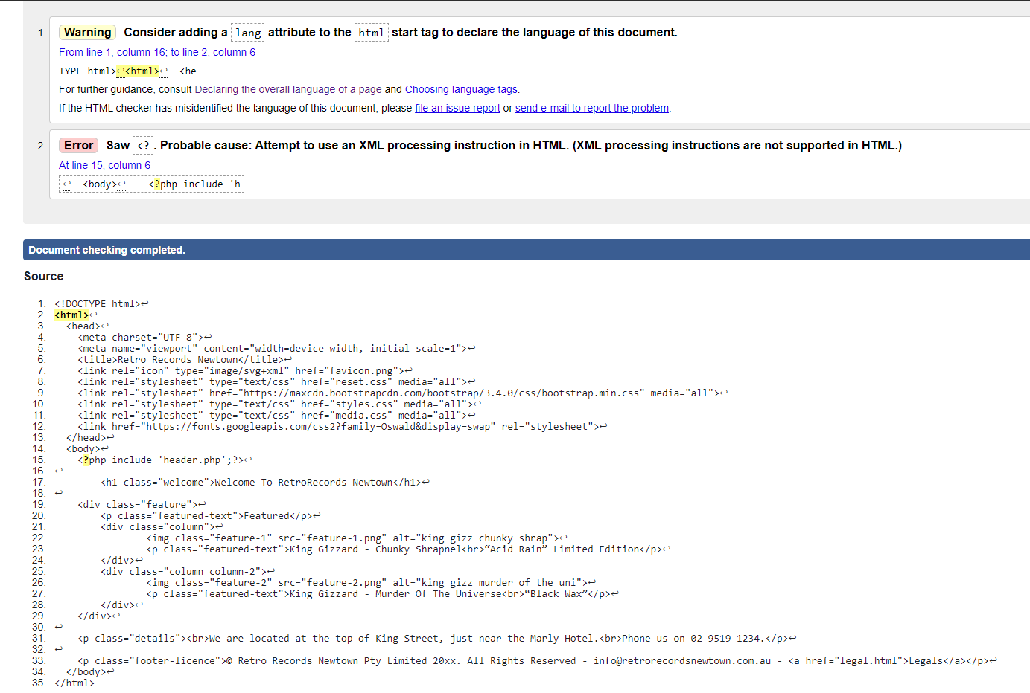

Validators pick php as errors as they were not designed for inclusion of php – however php validates fine on its own

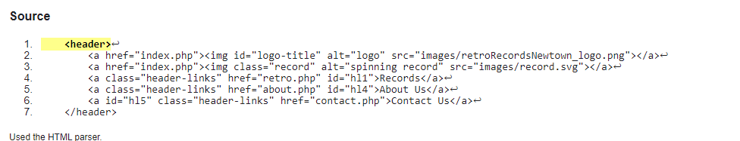

Error in header.php due to no defined language (this is an inserted file so irrelevant)

Error found where label for form inputs was not directed to their names, resolved

Every image has been given an alt

CSS

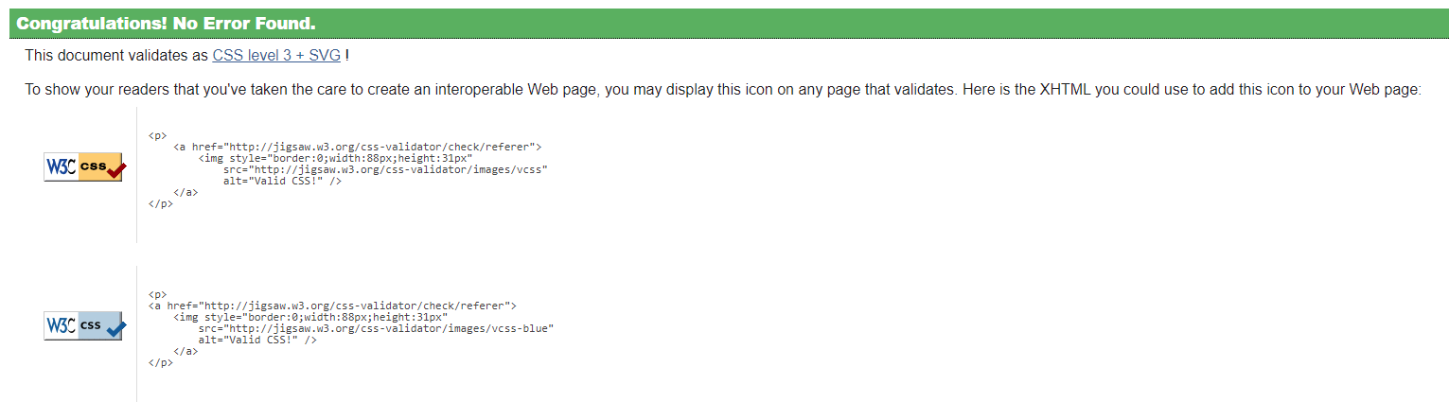

1. You must correct any issues and re-test your website until it displays correctly. Discuss this re-testing, including screenshots of different versions.

My biggest problem was positioning due to the header being fixed and covering elements

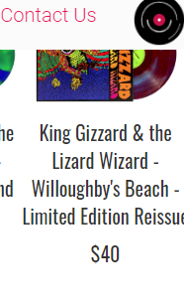

This was resolved through removal of display: fixed; on the header – since the documents are php, it also allows me to remotely restyle all pages headers

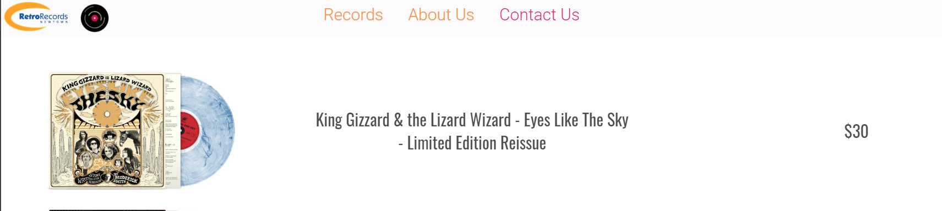

There was an issue where the records page would not be responsive and became unseeable as the resolution decreased

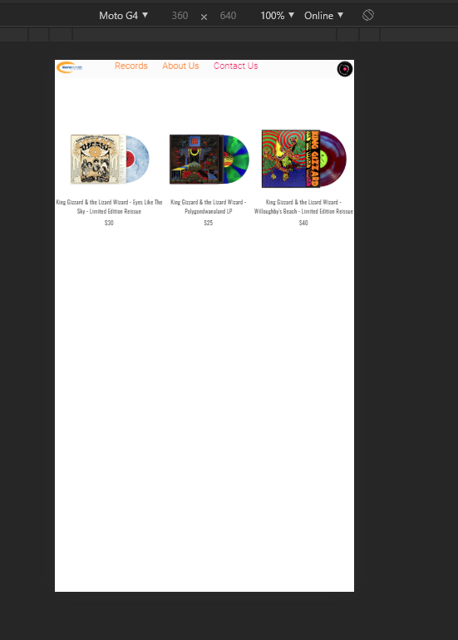

By converting to columns through a media query I was able to scale it and drop the titles into columns



While I was at it I rearranged the table layout on desktop

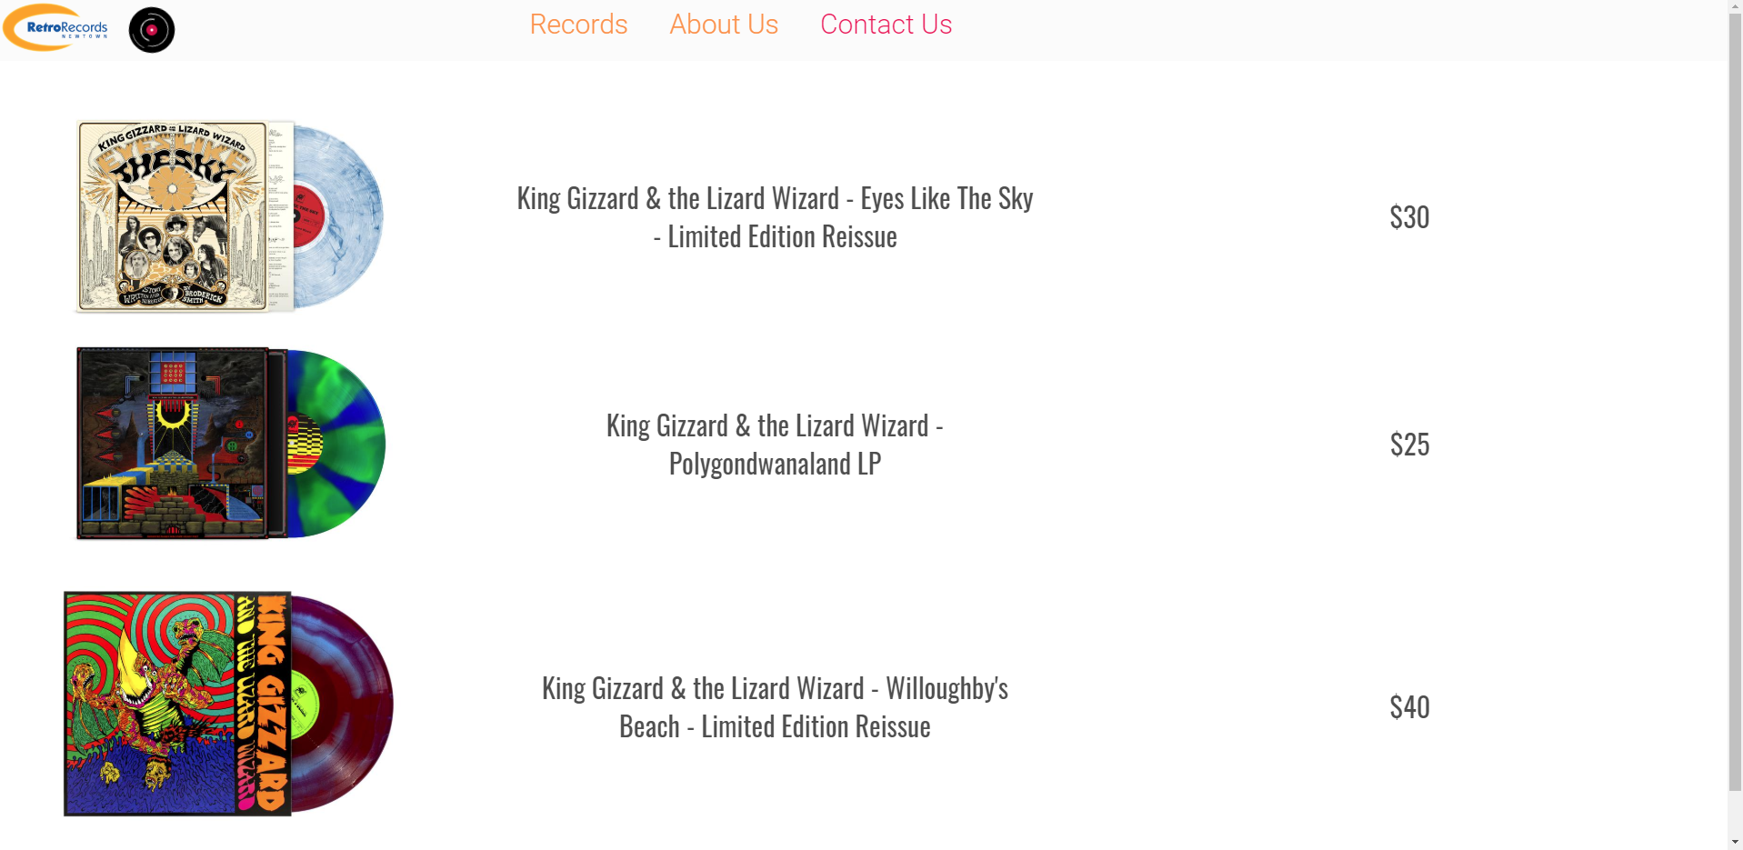

## Part 4: Correct errors

You have developed a website for another client, which displays two error messages during testing and validation, as follows.

1. Review the files in the website folder (Cl_Web_AE_Pro_2of2_SR2.zip). Determine the causes of the errors using a problem-solving process and make the appropriate changes to the website files.
2. In a word-processed document explain the errors that you found and the problem-solving processes that you used to determine the solution. Include evidence such as mind maps and decision trees.

The biggest thing that contributed to finding errors for me was through brute force checking – acting as a standard user would and navigating through every page and picking up on outstanding issues

A – Error in side menu placement on menu page

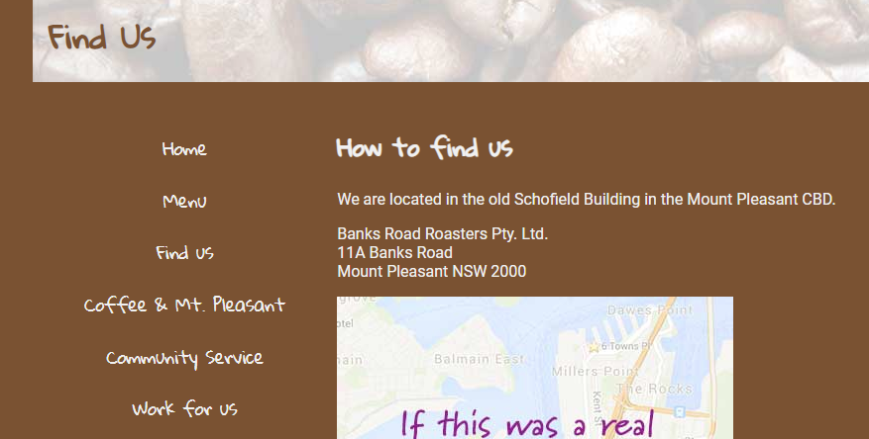 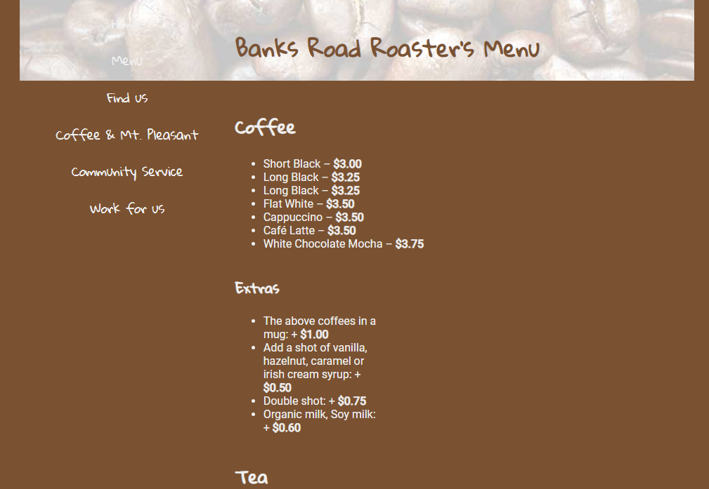

Cause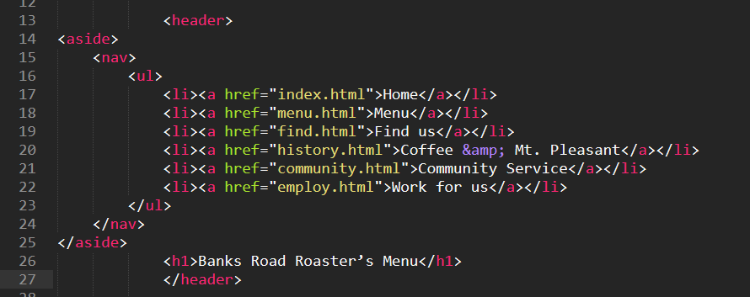

Fixed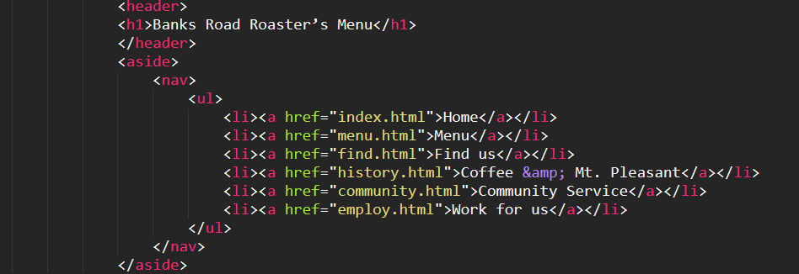

B – Menu is inaccessible from find us page

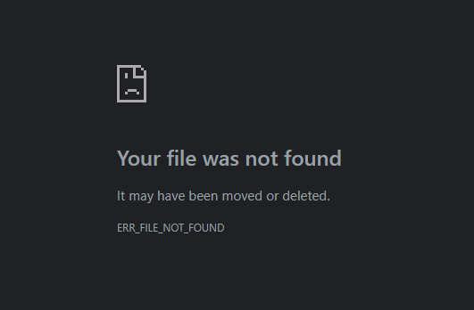 

Corrected missing L in “html”

C – Improper syntax

Muddled Code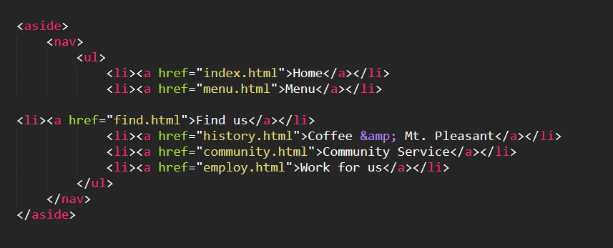

Correted childing and syntac throughout the menu page

D – Confusing footer content on menu page



Moved to top of the menu as it appears to be important for the customer and replaced with standard footer information



Unsure of the domain type for this email so changed to .com

Footer has now been centred into middle of page